Junit:

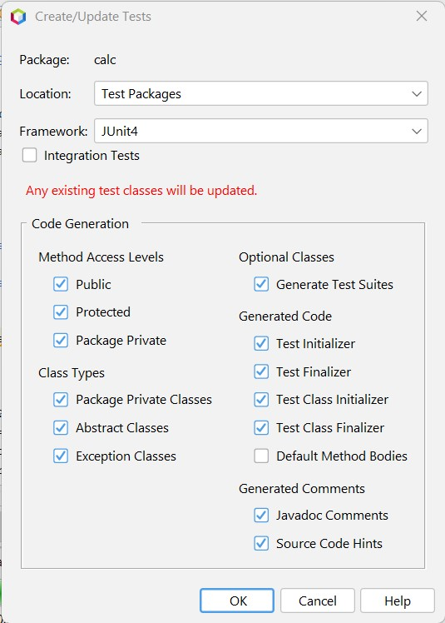

Min class

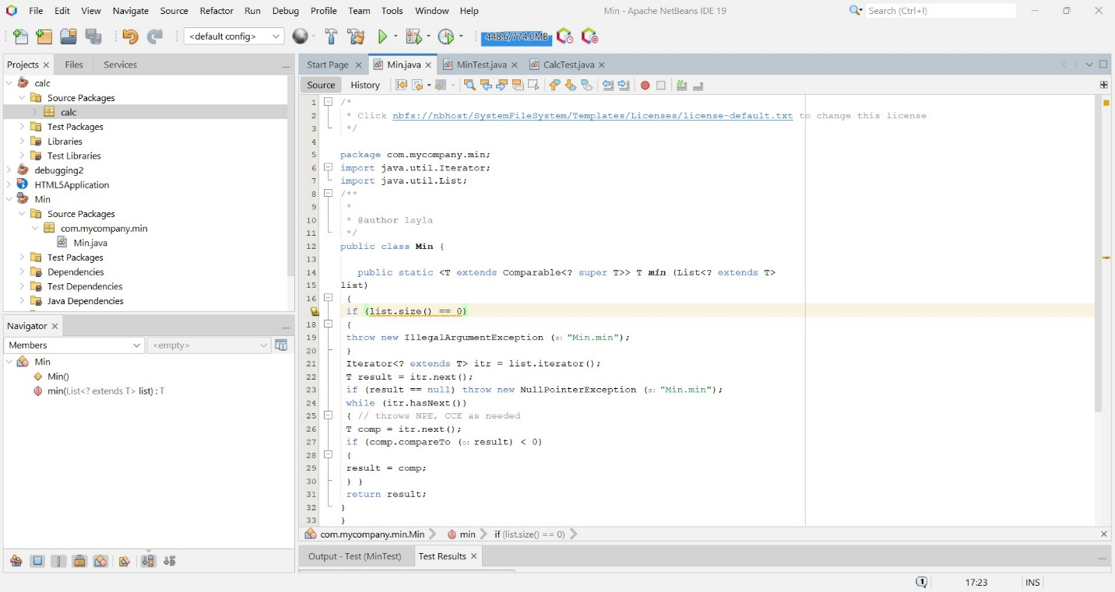

min test class

Test result and output

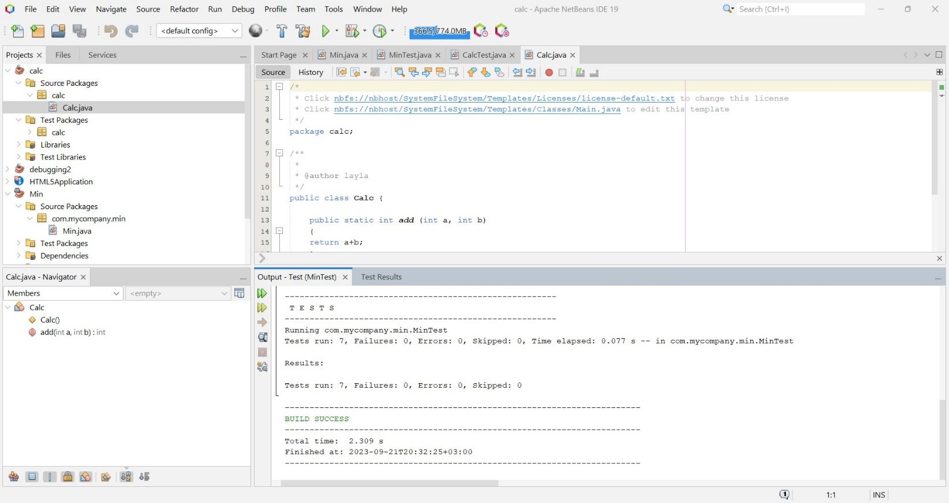

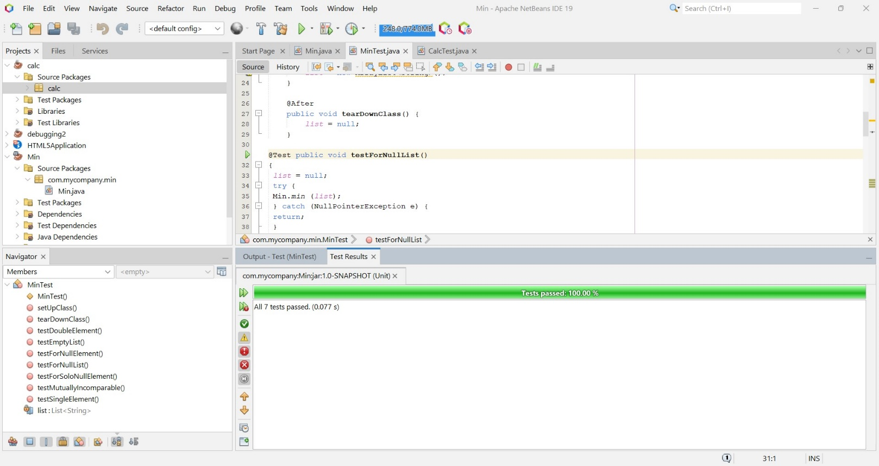

Calc class:

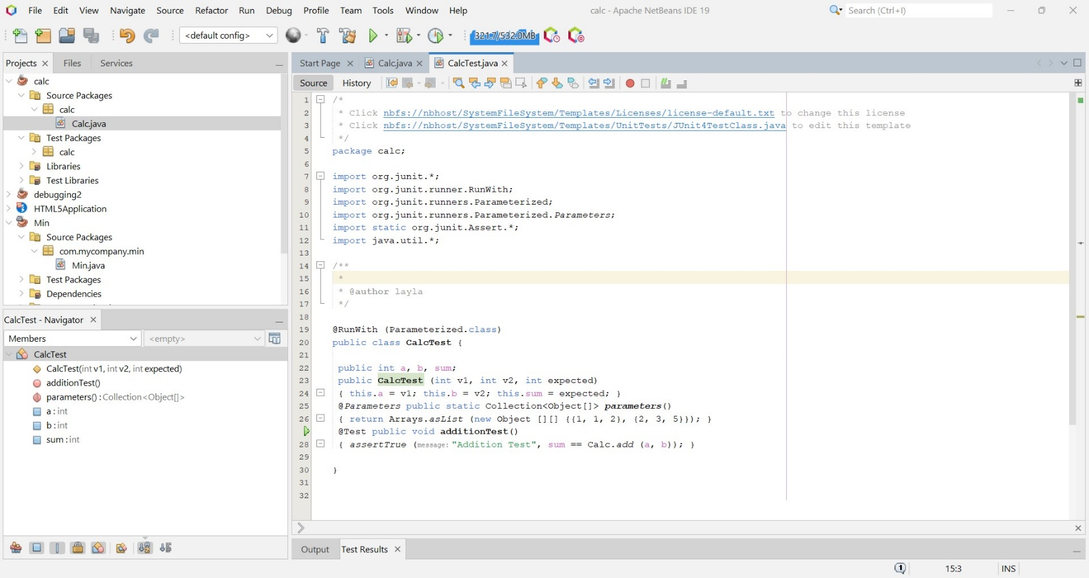Calc test class

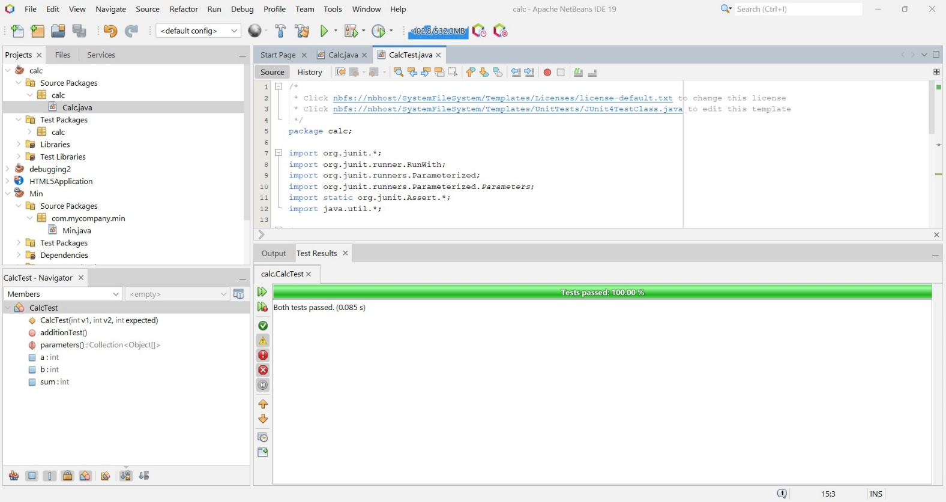Test results and test output:

